**Experiment 3: Use of Inline, Internal and External stylesheets and incorporating styles in HTML document.**

1. Create a CSS based Sticky footer.

**Index.html**

<!DOCTYPE html>

<html lang="en">

<head>

<meta charset="UTF-8">

<meta name="viewport" content="width=device-width, initial-scale=1.0">

<title>CSS Sticky Footer</title>

<link rel="stylesheet" href="styles.css">

</head>

<body>

<div class="wrapper">

  <div class="content">

    <h1>Main Content</h1>

    <p>This is the main content of the webpage.</p>

  </div>

</div>

<div class="footer">

  <p>This is a sticky footer.</p>

</div>

</body>

</html>

**Style.css**

html, body {

    margin: 0;

    padding: 0;

    height: 100%;

    display: flex;

    flex-direction: column;

  }

  .wrapper {

    flex: 1;

    display: flex;

    justify-content: center;

    align-items: center;

  }

  .content {

    text-align: center;

  }

  .footer {

    height: 50px;

    background-color: #333;

    color: #fff;

    text-align: center;

    width: 100%;

  }



1. Using HTML and CSS, create a custom hover and focus effect for navigation items, using CSS transformations.

**Index.html**

<!DOCTYPE html>

<html lang="en">

<head>

<meta charset="UTF-8">

<meta name="viewport" content="width=device-width, initial-scale=1.0">

<title>Modern Navigation</title>

<link rel="stylesheet" href="styles.css">

</head>

<body>

<nav>

  <a href="#" class="nav-item">Home</a>

  <a href="#" class="nav-item">About</a>

  <a href="#" class="nav-item">Services</a>

  <a href="#" class="nav-item">Contact</a>

</nav>

</body>

</html>

**Style.css**

body {

    font-family: Arial, sans-serif;

    margin: 0;

    padding: 0;

    background-color: #f4f4f4;

  }

  nav {

    background-color: #333;

    padding: 10px 20px;

  }

  .nav-item {

    display: inline-block;

    margin: 0 10px;

    padding: 10px 20px;

    color: #fff;

    text-decoration: none;

    border-radius: 5px;

    transition: background-color 0.3s, transform 0.3s;

  }

  .nav-item:hover,

  .nav-item:focus {

    background-color: #555;

    transform: translateY(-3px);

  }



1. Using HTML, CSS creates a zoom in zoom out animation.

**Index.html**

<!DOCTYPE html>

<html lang="en">

<head>

<meta charset="UTF-8">

<meta name="viewport" content="width=device-width, initial-scale=1.0">

<title>Zoom In Zoom Out Animation</title>

<link rel="stylesheet" href="styles.css">

</head>

<body>

<div class="container">

  <div class="box">

    <div class="content">

      <h1>Hii I'm Wasi.</h1>

      <p>Follow me on GitHub @reallywasi</p>

    </div>

  </div>

</div>

</body>

</html>

**Style.css**

.container {

    display: flex;

    justify-content: center;

    align-items: center;

    height: 100vh;

  }

  .box {

    width: 200px;

    height: 200px;

    background-color: #ee544f;

    border: 2px solid rgb(107, 47, 47);

    border-radius: 10px;

    overflow: hidden;

    position: relative;

    transition: transform 0.5s;

  }

  .content {

    text-align: center;

    padding: 20px;

  }

  .box:hover {

    transform: scale(1.8);

  }

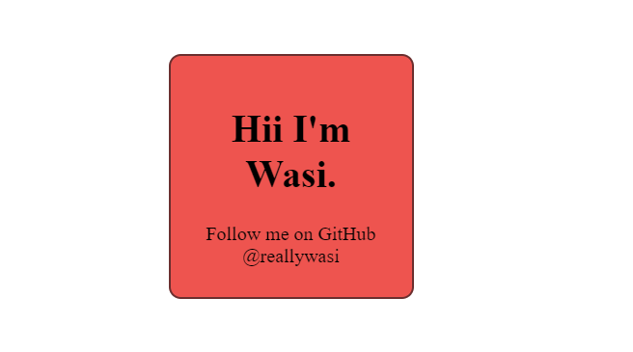 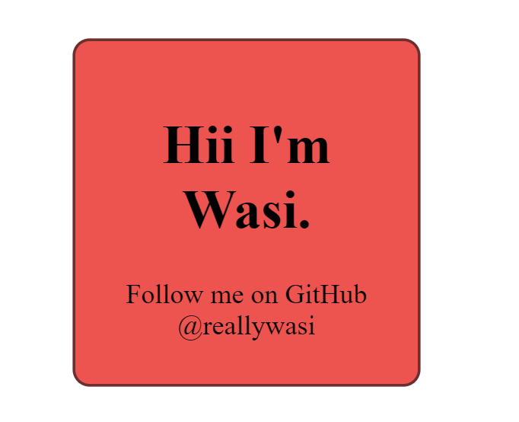

Before Hovering On hover